**INTRODUCTION**

**PROJECT TITLE: INSIGHT STREAM**

**TEAM MEMBERS**: 1) S. GOWRI SREE

2) S. ASFIYA BANU

3) S. MANISHA

4) K. MONISHA

**1.PROJECT OVERVIEW**:

Insight stream is a data analytics platform designed to provide real-time insights and visualizations for business, organizations, and individuals. The platform aims to simplify complex data analysis, enabling users to make informed decisions and drive growth. Data Ingestion may collect and process large datasets from various sources. In real-time analytics provide instant insights and visualizations for users.

**1.1 PURPOSE**:

* Business Intelligence
* Identifying trends and patterns
* Optimizing operations and process
* Enhancing customer

**1.2 FEATURES**:

* DATA MANAGEMENT
* Data ingestion
* Data Processing
* Data Storage
* SECURITY AND GOVERNANCE
* User Authentication
* Data Encryption
* Access Control

**2. ARCHITECTURE**

* Server and security logs
* Clickstream data from websites and apps
* IoT sensors
* Real-time advertising platforms

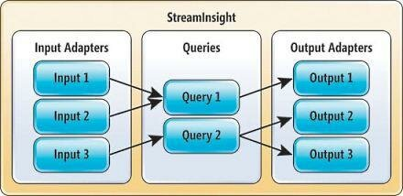**2.1 COMPONENT STRUCTURE**

**2.2 STATE MANAGEMENT**

* **Consistency:**

Proper state management ensures that data remains consistent across different components or modules of a system, preventing discrepancies and ensuring reliability.

* **Concurrency**:

In multi-user or distributed systems, effective state management allows for concurrent access to shared resources without conflicts or data corruption.

* **Performance**:

Efficient state management strategies optimize resource utilization and minimize latency, improving overall system performance and responsiveness.

* **Scalability**

Scalable state management solutions enable systems to handle increasing loads and user volumes without sacrificing performance or reliability.

* **Fault** **Tolerance**:

Robust state management mechanisms incorporate fault tolerance and resilience, allowing systems to recover gracefully from failures and maintain data integrity.

* **Maintainability**:

Well-organized state management facilitates system maintenance and evolution by providing clear separation of concerns and modularization of functionality.

* **Security:**

Secure state management practices protect sensitive data from unauthorized access or tampering, ensuring compliance with privacy and regulatory requirements

**2.3 ROUTING:**

It seems like you're exploring the concept of routing in the context of data streams, possibly related to Microsoft's StreamInsight platform. StreamInsight is a tool for Complex Event Processing (CEP), which processes high-speed data streams from multiple sources in real time. It enables tasks like querying, filtering, and correlating data streams to derive meaningful insights.

**4. SETUP INSTRUCTIONS**:

**Install the Software**:

Download and install the Insight Stream software or application on your device.

**Connect to Data Sources**:

Configure the input adapters to connect to your data sources. This could involve setting up APIs, databases, or other data streams.

**Define Queries**:

Use the query language provided by the platform to define how you want to process and analyze the data.

**Set Up Output Adapters**:

Configure where the processed data should go, such as dashboards, databases, or other systems.

**Test the Setup**:

Run test data through the system to ensure everything is working as expected.

**Monitor and Optimize**:

Continuously monitor the system's performance and make adjustments as needed.

**4.1 PREREQUISTIES**:

**Data Sources**:

Ensure you have access to the data streams or sources you want to analyze.

**Infrastructure**:

A compatible system or cloud environment to host the Insight Stream platform.

**Software Installation**:

Install the necessary software or tools required for Insight Stream.

**Configuration Knowledge**:

Familiarity with setting up input and output adapters, as well as defining queries.

**Access Permissions**:

Ensure you have the necessary permissions to access and process the data.

**4.2 INSTALATION**:

* Run the UiPathInsightsInstaller.exe installer as an administrator. The UiPath Insights Installer wizard is displayed.
* Select the Check here to accept the license agreement check box to agree to the terms in the agreement, then click Next. The Insights Server Configuration is displayed.
* Change the Server Configuration as desired.

**5. FOLDER STRUCTURE**: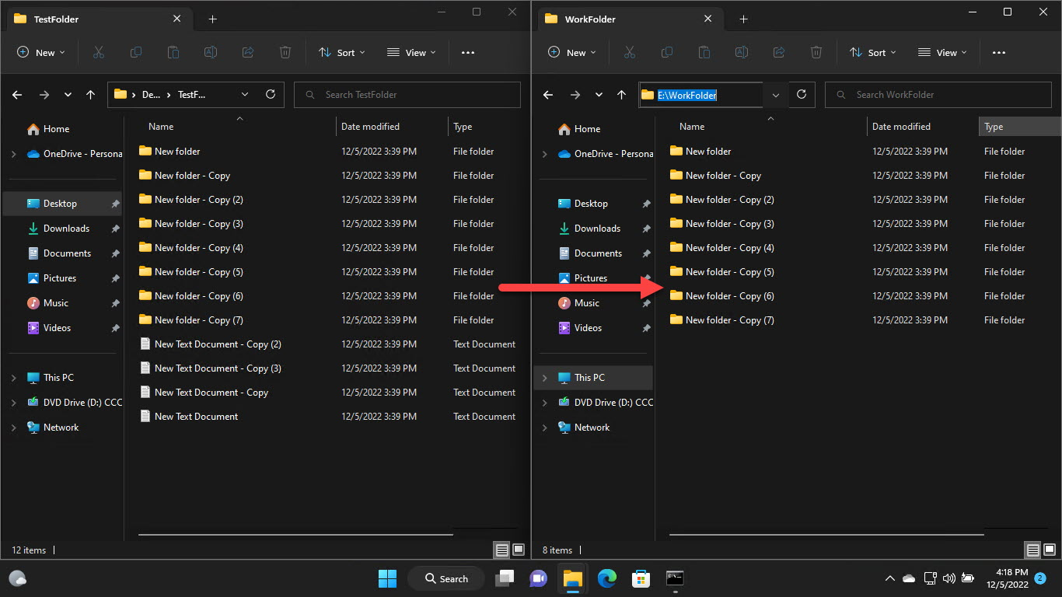

**5.1 CLIENT**:

**Insight OneCall Support**:

This service provides 24/7/365 IT troubleshooting and remote technical support for compute, network, storage, and cloud products. Clients can log in to the support portal to track and monitor issues or contact support via phone or email.

**Client Support Services**:

These services focus on maintaining maximum data center availability, preventing interruptions, and enhancing performance. They offer cost-effective solutions tailored to business needs.

**Value Stream Optimization**:

Insight provides guidance to optimize processes, reduce operational costs, and create actionable improvement roadmaps for sustainable growth.

**5.2 UTILITIES:**

**Real-Time Data Analysis**:

It can process and analyze data streams in real-time, which is useful for industries like finance, healthcare, and manufacturing.

**Classroom Engagement**:

In educational settings, Insight Stream can use AI to analyze student emotions and engagement during lessons, helping teachers adapt their methods for better outcomes.

**Event Monitoring**:

It can monitor events and detect anomalies, making it valuable for security and operational efficiency.

**Process Optimization**:

Insight Stream can help businesses optimize workflows and improve decision-making by providing actionable insights.

**6. RUNNING THE APPLICATION:**

**Setup and Installation**:

* Ensure the application is installed on your system or accessible via the cloud.
* Verify that all necessary dependencies and configurations are in place.

**Login and Configuration**:

* Log in using your credentials.
* Configure the application settings to suit your specific use case, such as data sources, processing rules, or output formats.

**Data Integration**:

* Connect the application to your data streams or sources.
* Test the connection to ensure data is being received correctly.

6.1 PROVIDE COMMANDS TO START FRONTEND SERVER LOCALLY.

• **Navigate to the Project Directory**:

bash

cd /path/to/your/project

• **Install Dependencies** (if not already installed):

bash

npm install

• **Start the Development Server**:

bash

npm start

or, if you're using Yarn:

bash

yarn start

• **Access the Application**:

Open your browser and go to http://localhost:3000 (or the port specified in your configuration).

**6.2 FRONTEND: NPM START IN CLIENT DIRECTORY.**

bash

npm start

This command will launch the development server, and you can access the application in your browser, typically at http://localhost:3000 (unless a different port is specified in the configuration).

If you encounter any issues, ensure that:

1. All dependencies are installed (npm install).
2. You're in the correct directory containing the package.json file.

**7. COMPONENT DOCUMENTATION**:

* A GitHub repository that seems to include documentation for Insight Stream.
* Another GitHub repository with a README file that might provide insights into its components.
* A PDF document related to Insight Stream's development, which could include component details.

**7.1 KEY COMPONENTS**:

**Data Ingestion**:

This component handles the collection of data from various sources, such as IoT devices, databases, or APIs, ensuring seamless integration.

**Real-Time Processing**:

Insight Stream processes data in real-time, enabling quick analysis and decision-making.

**Visualization Tools**:

These tools present data and insights in an intuitive and user-friendly manner, often through dashboards or reports.

**Alerting and Notifications**:

Insight Stream can trigger alerts or notifications based on predefined conditions, ensuring timely responses to critical events.

**7.2 REUSABLE COMPONENTS**:

It seems like you're looking into reusable components, possibly in the context of automation or software development. Reusable components are essentially pre-built modules or workflows that can be used across multiple projects to save time and ensure consistency.

For example, in platforms like UiPath, reusable components can be workflows or libraries that are packaged and reused in various automation processes. These components can include functionalities like login/logout workflows, data processing modules, or even machine learning models2.

If you're exploring this for a specific project or tool, feel free to share more details, and I can help tailor the information further!

**8. STATE MANAGEMENT**

• **State Storage**:

Where the state is stored, such as in-memory, on disk, or in distributed storage systems.

• **State Operations**:

How the state is updated, queried, or deleted during data processing.

• **Fault Tolerance**:

Mechanisms like checkpointing or replication to recover the state in case of failures.

• **Scalability**:

Ensuring the state management system can handle increasing data volumes and processing demands.

**8.1 GLOBAL STATE**:

It seems like you're exploring the concept of a "global state" in the context of Insight Stream. In software or data systems, a global state typically refers to a centralized repository of information that is accessible across different components or modules of the system. This can be particularly useful for maintaining consistency and enabling seamless communication between various parts of the system.

For example, in a streaming data platform, the global state might include metadata about the streams, configuration settings, or aggregated results from real-time processing. Managing this state effectively is crucial for ensuring scalability, fault tolerance, and efficient data processing.

If you have a specific use case or tool in mind, feel free to share more details, and I can provide tailored insights!

**8.2 LOCAL STATE:**

**• Efficiency**:

Local state allows for faster access and updates since the data is stored close to where it's being processed.

• **Fault Tolerance**:

Systems often use mechanisms like checkpointing to periodically save the local state, ensuring recovery in case of failures.

• **Use Cases:**

Local state is commonly used for operations like aggregations, joins, and windowed computations in stream processing.

**9. USER INTERF**ACE:

• **Educational Applications**:

In classroom environments, Insight Stream's UI might include real-time dashboards that display student engagement metrics, emotional analysis, and other insights derived from AI-powered facial recognition. This helps educators adapt their teaching methods dynamically.

• **Network Analysis**:

In tools like OPNsense, Insight Stream's UI offers graphical overviews, pie charts, and detailed views for analyzing network traffic. It allows users to filter data, view top users, and export reports for further analysis.

• **Development Projects**:

For developers, Insight Stream's UI might be integrated into platforms like GitHub, providing a straightforward interface for managing and collaborating on projects.

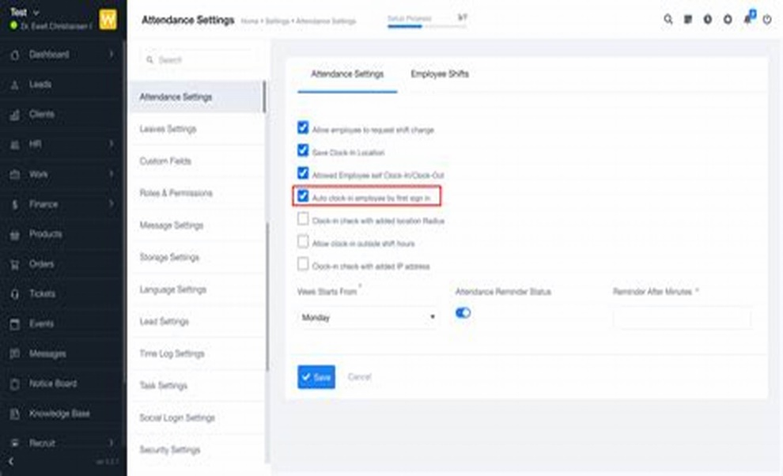9.1 PROVIDE SCREENSHOT OR GIFs SHOWCASE IN DIFFERENT UI FEATURES SUCH AS PAGES FORMS OR INTERACTION.

**10. STYLING**

It seems like you're referring to "Insight Stream," which is a feature used in platforms like Conductor and Siteimprove. Insight Stream is designed to provide curated insights, performance metrics, and actionable recommendations, often for SEO and marketing purposes. It helps users focus on key data without being overwhelmed by excessive information.

For example, Conductor's Insight Stream offers a live feed of search insights and KPIs, allowing teams to collaborate, share insights, and make data-driven decisions efficiently. Similarly, Siteimprove's Insight Stream leverages AI to prioritize relevant information and streamline team communication

**10.1 CSS FRAMEWORK/LIBRARIES**:

• **Bootstrap**:

Known for its responsive grid system and pre-designed components.

• **Tailwind CSS**:

A utility-first framework for highly customizable designs.

• **Bulma**:

A modern framework based on Flexbox for clean and modular layouts.

• **Foundation**:

Offers advanced responsive design capabilities.

**10.2 THEMING**

**Primary Colors**: Used for accents and interactive elements.

**Background Colors**: For main content areas and sidebars.

**Text Colors**: To ensure readability.

**Fonts**: Options like serif, sans-serif, or monospace.

**11. TESTING**:

Stream insight product test enables brands create interest encourage conversations and push the word of mouth through a buzz marketing strategy on targeted verticals.

**11.1 TESTING STRATEGY**

A Testing strategy is a high level document that outlines the overall approach and guiding principles for software testing.

11.2 CODE COVERAGE

Code coverage option is available under the test menu when you run test methods using text explorer

**12. SCREENSHOTS AND DEMO**

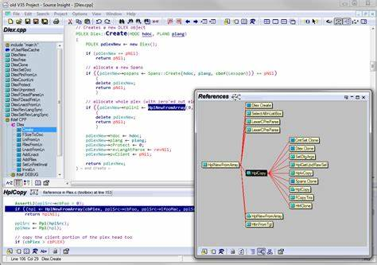

**13. KNOWN ISSUES:**

I couldn't find specific information about known issues related to Insight Stream. However, if you're encountering challenges or need troubleshooting assistance, I recommend checking the official documentation or support channels for Insight Stream. Let me know if you'd like help finding those resources or exploring alternative solutions.

**14. FEATURE ENHANCEMENT**:

**Personalized Insights**:

It provides a live feed of tailored search insights and key performance indicators (KPIs), allowing users to focus on what matters most.

**Actionable Recommendations**:

Insight Stream proactively delivers relevant information, enabling users to take immediate action and drive meaningful results.

**Collaboration Tools**:

Users can easily share insights with their teams, streamlining communication and decision-making.

**Customization Options**:

The platform allows users to filter and prioritize insights based on their specific goals2.

**Integration Capabilities**:

It seamlessly integrates with existing workflows, making it easier to track and act on insights